Nama : Ade Neviyani

Nim : 018

* 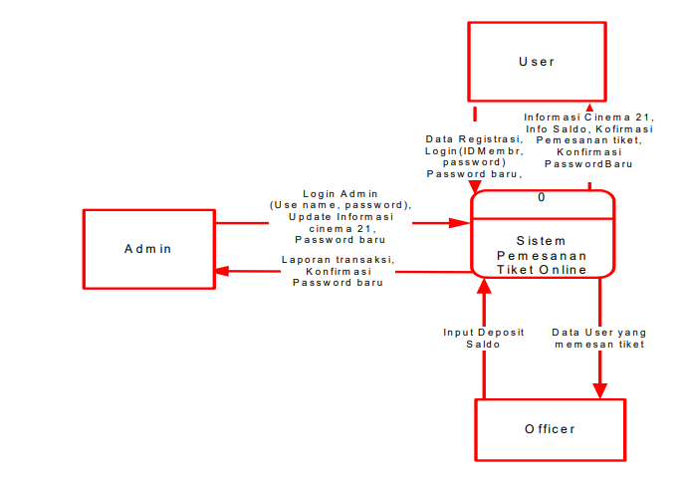diagram konteks
* 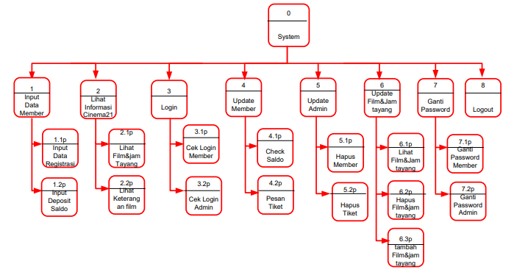descomposition diagram
* 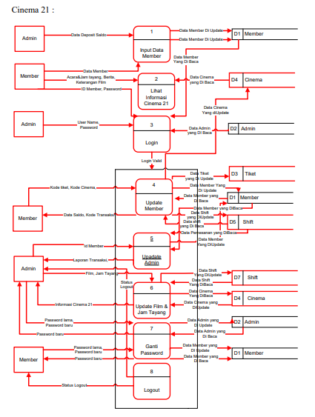overview diagram

* Overview diagram level 0

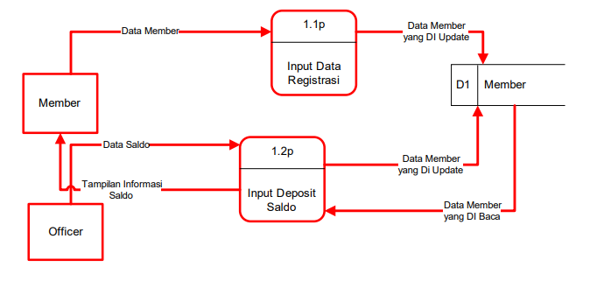

* 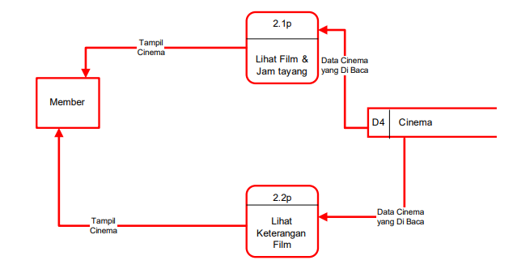overview diagram level 1 proses 1
* 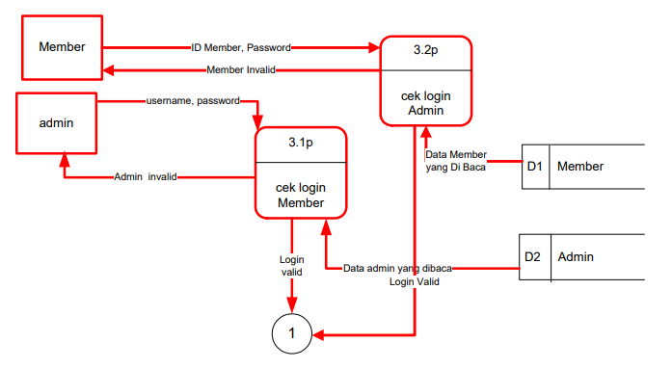Overview diagram level 1 proses 2
* Overview diagram level 1 proses 3

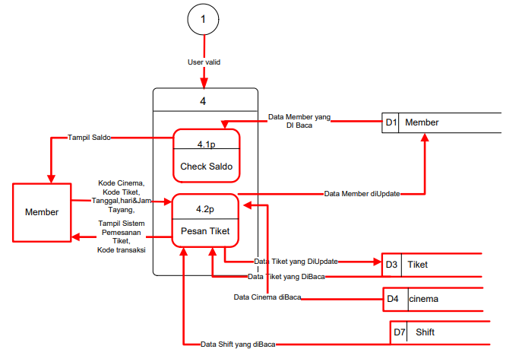

* 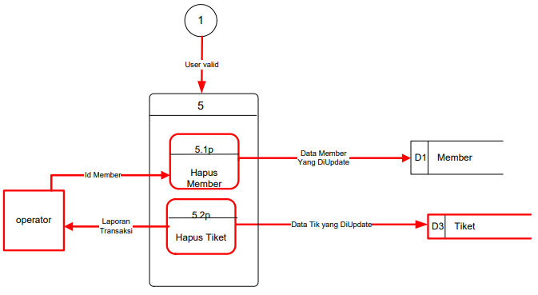Overview diagram level 1 proses 4
* 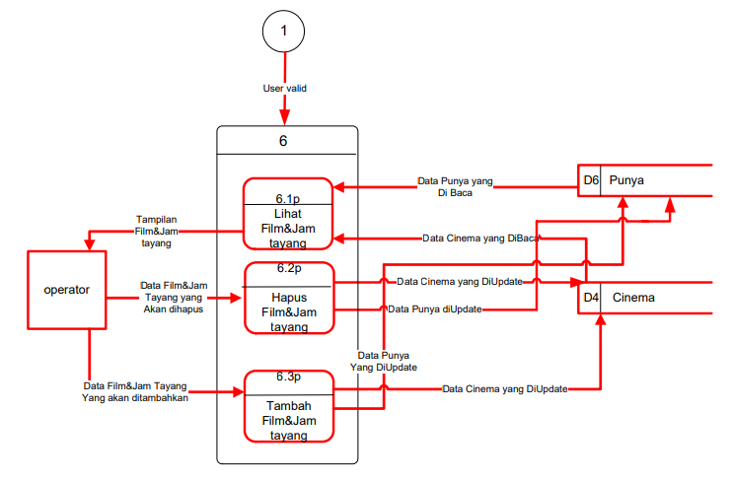Overview diagram level 1 proses 5
* 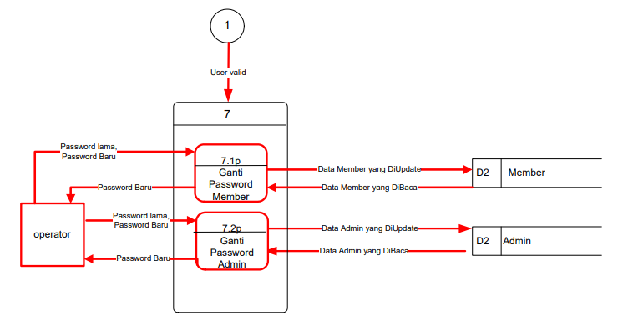Overview diagram level 1 proses 6
* Overview diagram level 1 proses 7

